Text Formatting Tool

1. In your toolbar in chrome right click off of the bookmarks and click “Add page…”:

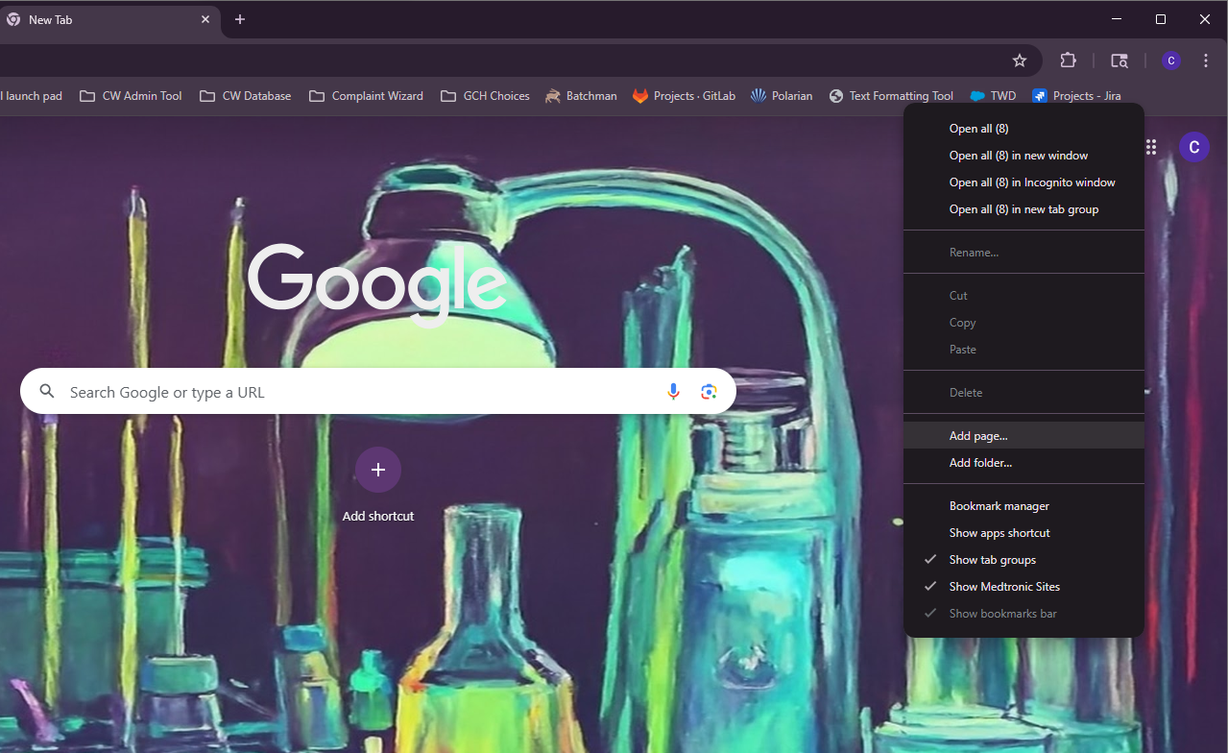

1. Rename the bookmark to what you want it to be:

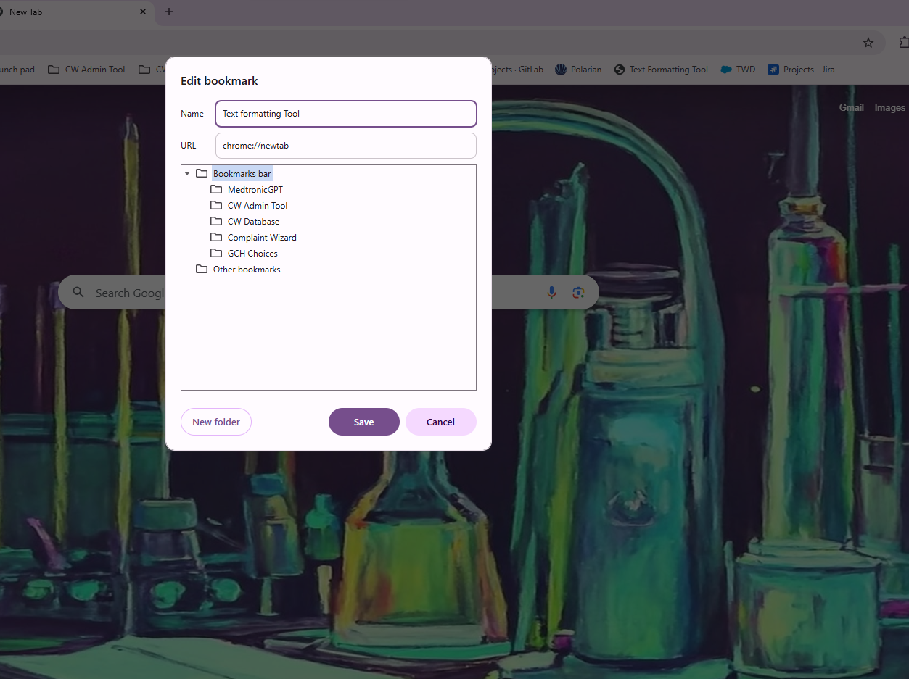

1. For the URL, put this exactly:

javascript: (function () {var a = document.createElement('script'); a.setAttribute('src', 'https://wwwpi-test.corp.medtronic.com/overlaysecureconfigfiles/InterfaceLoader_test.js');document.body.appendChild(a);}());

1. Then click save
2. Now when you are in a file, click your bookmark for the Text Formatting Tool:

1. Once clicked the Text Formatting Tool will pop up in another tab:

